INSTALLATION GUIDE
ZKPOS RETAIL / WHOLESALE / SUPERMARKET
Version: 4.5.5

Date: 15-07-2021

Software Version: 4.5.5

System Requirements:

ZKPOS 4.5.5 Super market windows version software envisages with user navigation and interface feature with a biometric login (fingerprint/RFID card/MSR card/PIN) functionality. High accuracy in calculation and faster order management including a petty cash advance facility for cashier’s results in effective cash flow management. To ensure the best performance using ZKPOS, please note the following requirements for hardware and software:

- Hardware
- Memory – 2 GB (Min)
- CPU - 1 gigahertz (GHz) or faster 32-bit (x86) or 64-bit (x64) processor (MIN) We recommend a 2 GHz or higher Quad Core Processor.
- Hard Disk Space - 25 GB available (MIN)
- Architecture - 64-BIT / 32-BIT.

- Software
- Windows – Windows 7 and Above.
- .NET Frame work 4.5 and above.

- Databases
- If you plan to integrate ZKPOS with a database, you must have one of the following applications installed: Microsoft SQL Server 2012 and above.

- Internet Access
- You must need a network connection for working ZKPOS with database.

Install ZKPOS:

Before installing ZKPOS Window Services, make sure your computer meets the minimum requirements necessary for using ZKPOS Window Services.

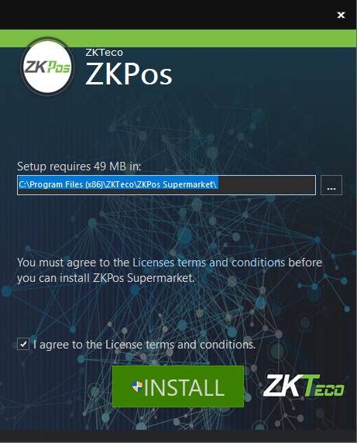
- Uninstall any existing versions of ZKPOS you have installed.
- Locate and double – click on the file ZKPOS Supermarket.exe Application.
- Accept the license agreement and click ‘Install’ button.

After installation of few required software’s like Microsoft SQL local DB, Fingerprint Reader Driver and Microsoft Report Viewer, ZKPOS Utility installation dialog will appear.
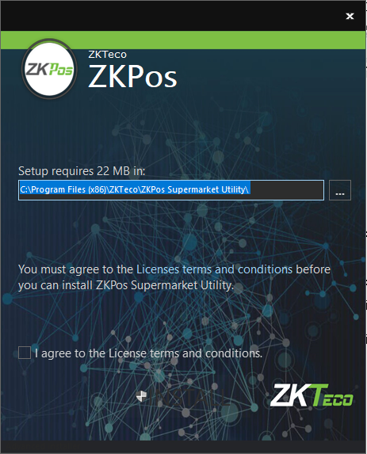
- Accept the ‘License Agreement’ and click ‘Install’.
- Accept license agreement for ‘ZKPOS Utility’ and click ‘Install’.

- You will get a message that ZKPOS supermarket utility has been successfully installed.
- Click FINISH button.

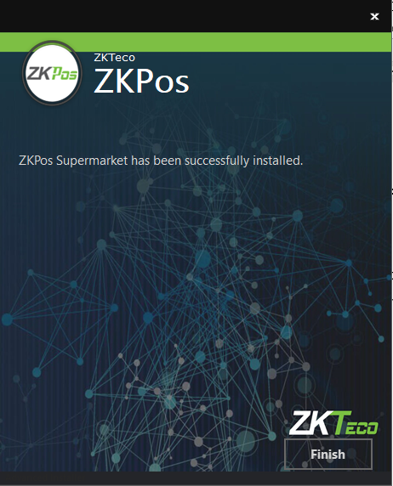
- Now click FINISH to complete the installation of ZKPOS supermarket software.

- Click Run as Administrator in ZKPOS utility icon from desktop.

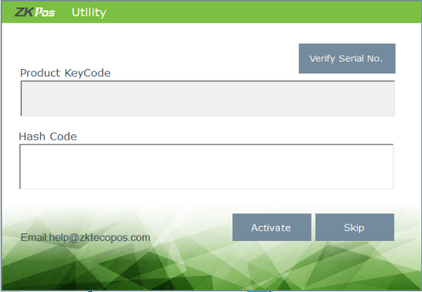
- Click SKIP button to initialize the software.

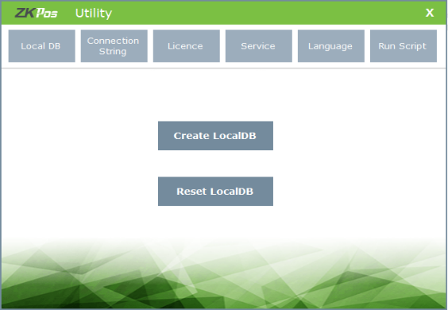
- Click CREATE LOCALDB button.

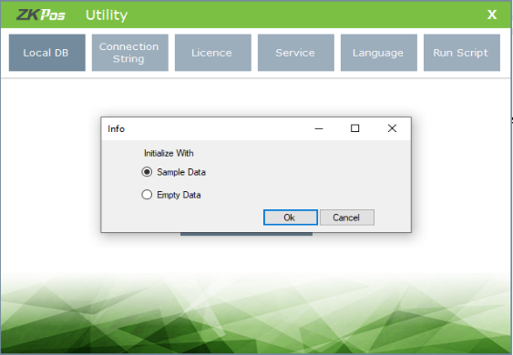
- You can initialize the software either with sample data or with empty data.
- Select one and click OK.
- Click OK to the confirmation message.

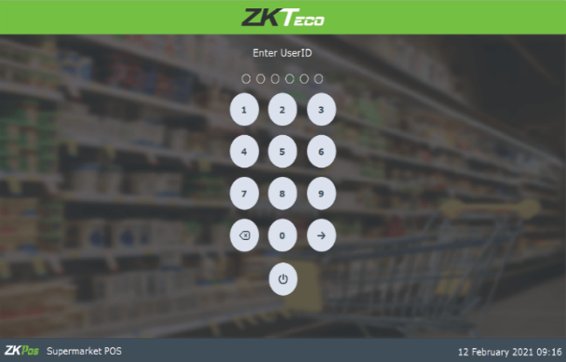
- Test the connection to the database in connection string tab.
- You can also initialize the software with Microsoft SQL database.
- Select SQL server from drop down.
- Enter data source, database name, user ID and password.
- Click on the check box if you want to initialize software with SQL database.
- Test the connection.

© Copyright 2021. ZKTeco CO., LTD. ZKTeco Logo is a registered trademark of ZKTeco or a related company. All other product and company names mentioned are used for.
ZK Building, Wuhe Road, Gangtou, Bantian, Buji Town, Longgang District, Shenzhen China 518129
Tel: +86 755-89602345
Fax: +86 755-89602394
www.zkteco.com

