INSTALLATION GUIDE
ZKPOS RETAIL / WHOLESALE / SUPERMARKET BACK OFFICE

Version: 4.0.0
Date: 15-01-2021
Software Version: 4.0.0

SYSTEM REQUIREMENTS:
To ensure the best performance using ZKPOS Supermarket Back Office, please note the following requirements for hardware and software:

- Hardware: Memory: 1 GB (Min)
Processor: i5
Ram: 4GB (MIN)
Hard Disk Space: 4 GB available (MIN)

- Software: ASP.net: ASP.net version 2017 and above.
Internet Information Service (IIS) 7.5 and Above.

- Databases: Microsoft SQL Server 2012 and above.

- Internet Access: You must need a network connection for working ZKPOS Supermarket BO.

- Installing and Configuring ZKPOS Supermarket Application:
You must want to install and configure ZKPOS Supermarket BO exe on your system.

1.1. To install ZKPOS Supermarket on Your System:
  - Uninstall any existing versions of ZKPOS Supermarket Application you have installed.
  - Locate and Click the file ZKPOS Supermarket BO.exe
  - Double Click on ZKPOS Supermarket BO.

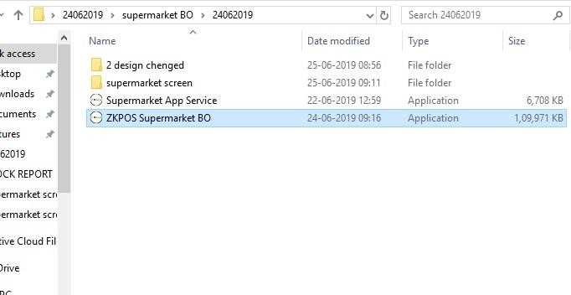

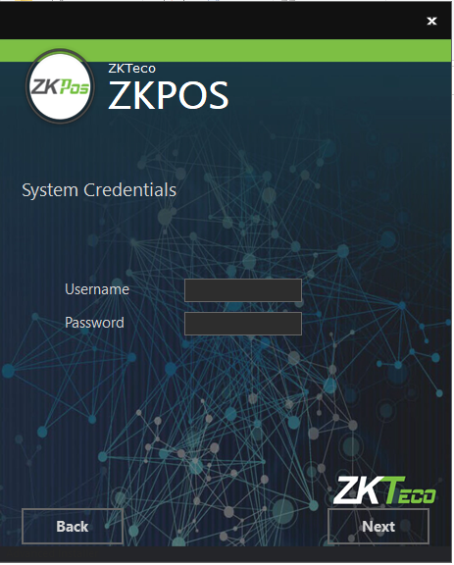
  - Enter username and password of the system you installed the ZKPOS Supermarket back Office
  - Click Next button.

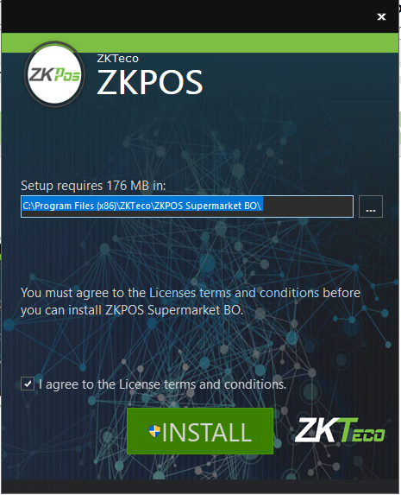
- Click INSTALL button.

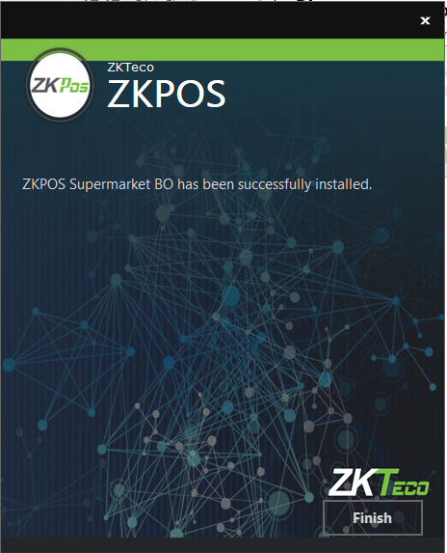
- Click FINISH button.

1.2. INTERNET INFORMATION SERVICE (IIS) MANAGER CONFIGURATION:
- Enable Internet Information Services (IIS) Manager.
- Open Control Panel – Click Turn Windows features on or off, it will show the picture listed below.

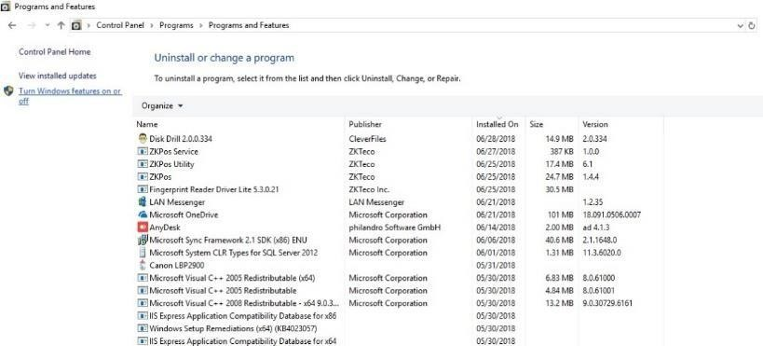

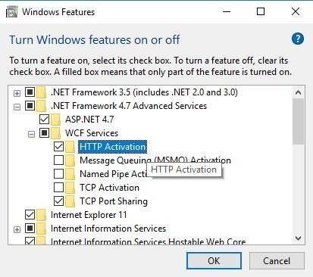
- After clicking the windows features turn on or off you has been seen a popup Window of windows Features.
- Activate HTTP Activation.
- Expand .NET Frame work 4.5 and above.
- Select Internet Information Services (IIS)
- Click OK.

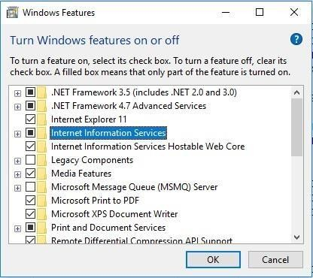
- After clicking the windows features turn on or off you has been seen a popup Window of windows Features.
- Activate HTTP Activation.
- Expand .NET Frame work 4.5 and above.
- Select Internet Information Services (IIS).
- Click OK.
- After Internet Information Services (IIS) is enabled, please Restart the system.

1.3. To Configure ZKPOS Supermarket on Your System:

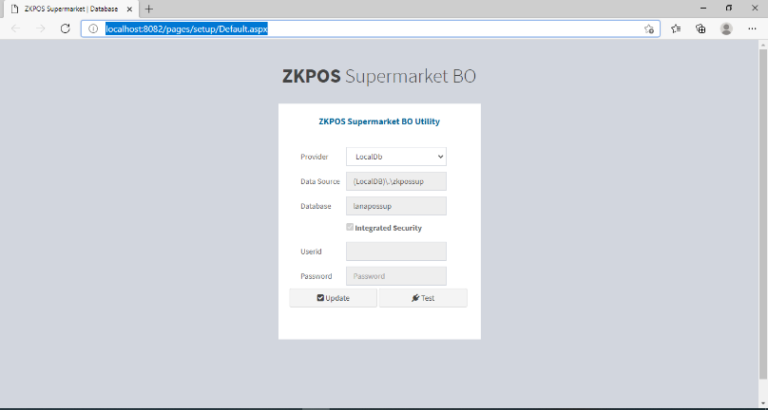

- After installation finishes you have to see ZKPOS Supermarket Back office icon on the Home screen Open it.
- Browse ZKPOS Supermarket / Database.
- Enter database details.
- Click update and test the connection with database.
- Click ok to the successful message.
- Click on Go login button.
- Enter USER NAME and PASSWORD.

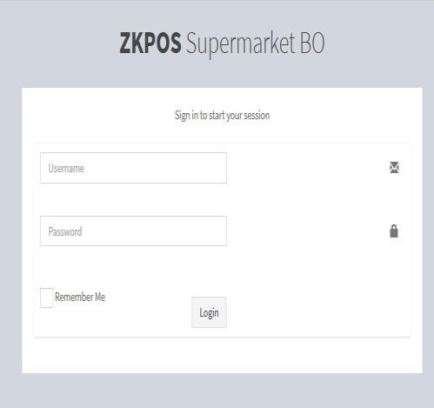

© Copyright 2020. ZKTeco CO., LTD. ZKTeco Logo is a registered trademark of ZKTeco or a related company. All other product and company names mentioned are used for.
ZK Building, Wuhe Road, Gangtou, Bantian, Buji Town, Longgang District, Shenzhen China 518129
Tel: +86 755-89602345
Fax: +86 755-89602394
www.zkteco.com

